**First Come First Served**

Here, the process that comes first is executed first. Which means they are executed in the same order as they come.

This algorithm can be implemented by using FIFO (First In First Out) queue.

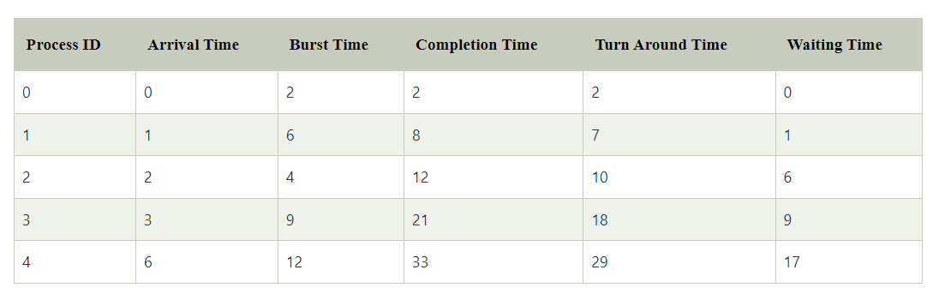

Also have to find the average turnaround and waiting time.